Walking route from Needles Eye Café to Jaunt-ebikes Keyhaven HQ

Lovely 30 mins coastal stroll
Combination of path, promenade, gravel track and country lane terrain
Map key: blue dotted line

Before your set off……..Please be aware that we get very busy and our bikes get fully booked very quickly!! To avoid disappointment, don’t forget to pre-book your e-bikes online or call us on 07846 395684 before walking to us as – walk in availability cannot be guaranteed.

- Hop off the bus at the Needles Eye Café on Milford on Sea seafront

- At Hurst Road East car park proceed East towards The Lighthouse Restaurant (white building, direction of Hurst Castle). Grab a bird’s eye view of the Isle of Wight and its famous Needles

- At Lighthouse Restaurant, walk through the car park to join the gravel track past Sturt Pond Nature Reserve (on your left). Check out the myriad birdlife

- Continue forward and cross the second wooden bridge and join Saltgrass Lane (keeping the sea and Isle of Wight on your right)

- Continue along Saltgrass Lane for 500 yds and once you reach Hurst Castle Sailing Club, bear left onto Keyhaven Road

- Continue forward and pass the Gun Inn on your left and the War Memorial on your right.

- After about 100 yds you will see the Jaunt-ebikes HQ flag on the right hand side of the road, enter the farm yard through the wooden gates. Welcome!

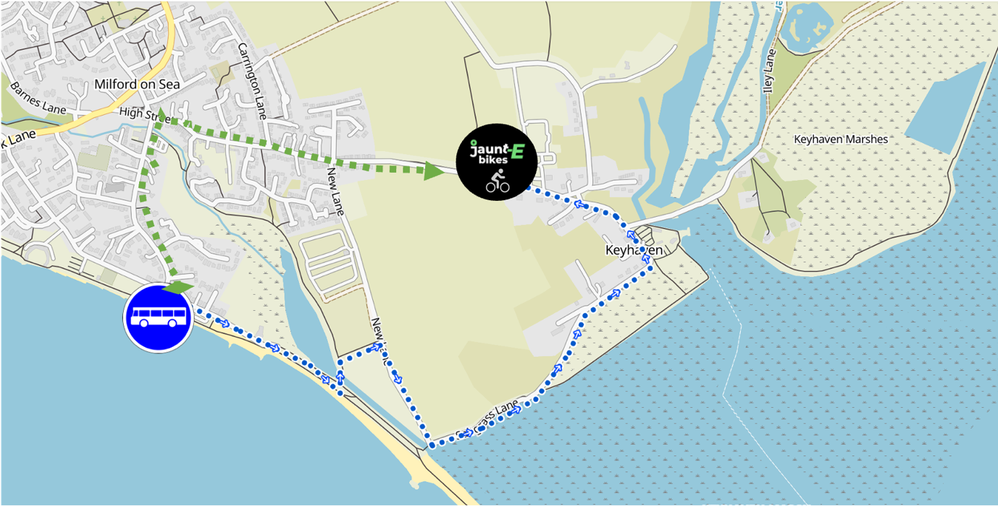

Alternative walking route from Needles Eye Café to Jaunt-ebikes Keyhaven HQ

If you prefer a slightly quicker walk on slightly more even ground you can follow this alternative route that takes in Milford on Sea Village centre

Map key: green dotted line

- Hop off the bus at the Needles Eye Café on Milford on Sea seafront
- Cross the road and continue along Sea Road into
- Pass Milford on Sea Community Centre and car park and upon reaching the Smugglers Inn pub in the village centre, bear right onto Keyhaven Road
- Continue forward down Keyhaven Road – when the path ends you can walk along the roadside for about 1km
- You will see the Jaunt-ebikes HQ flag on the left hand side of the road, enter the farm yard through the wooden gates. Welcome!

